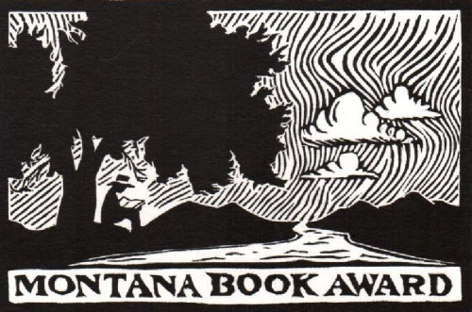
2021 Nomination Form

Date:
Author:
Title:
Publisher/ISBN:
Nominated by:
E-mail:
Reason for nomination:

NOTE: Eligible titles must be published during the 2021 calendar year.
At least six copies of the nominated title must be submitted with this form. Publishers can submit finished books, Advanced Reading Copies or digital editions.
To allow committee members time to read all nominated titles, early submission is encouraged. Nominations must be postmarked by December 10, 2021

Montana Book Award P.O. Box 8732 Missoula, Montana 59807-8732
www.montanabookaward.org MontanaBookAward@gmail.com

