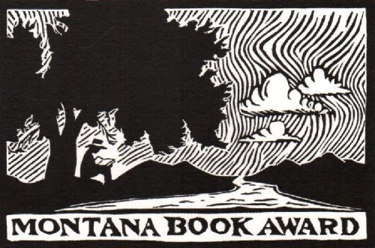
Montana Book Award | 455 E Main St | Missoula, Montana 59802
www.montanabookaward.org | MontanaBookAward@gmail.com

2024 Nomination Form
Titles eligible for the Montana Book Award must be published during the 2024 calendar year.
Date of nomination:
Author:
Title:
Publisher/ISBN:
Nominated by:
E-mail:
Reason for nomination:

In the event this title is selected as a winner, please provide the following author contact information:
E-mail:
Phone number:
To allow committee members time to read all nominated titles, early submission is encouraged. Nominations must be postmarked by December 10, 2024.
Nine copies of the nominated title must be provided for members of the reading committee by December 31, 2024. Publishers can submit finished books or Advanced Reading Copies. Digital editions may be submitted, so long as print copies of the nominated title are provided by the end of the calendar year for 2024.

